Machine learning

**Amazon Rekognition**

* Find **objects, people, text, scenes** in **images and videos** using ML
* Facial analysis and facial search to do user verification, people counting
* Create a database of “familiar faces” or compare against celebrities
* Use cases:
* Labeling
  + Content Moderation
  + Text Detection
  + Face Detection and Analysis (gender, age range, emotions…)
  + Face Search and Verification
  + Celebrity Recognition
* <https://aws.amazon.com/rekognition/>

**Amazon Transcribe**

* Automatically **convert speech to text**
* Uses a deep learning process called automatic speech recognition (ASR) to convert speech to text quickly and accurately
* Use cases:
  + transcribe customer service calls
  + automate closed captioning and subtitling
  + generate metadata for media assets to create a fully searchable archive

**Amazon Polly**

* Turn **text into lifelike speech** using deep learning
* Allowing you to create applications that talk

**Amazon Translate**

* Natural and accurate **language translation**
* Amazon Translate allows you to localize content - such as websites and applications - for international users, and to easily translate large volumes of text efficiently.

## Amazon Lex & Connect

### Amazon Lex: (same technology that powers Alexa)

* Automatic Speech Recognition (ASR) to convert speech to text
* Natural Language Understanding to recognize the intent of text, callers
* Helps build chatbot, call center bots

### Amazon Connect

* Receive calls, create contact flows, cloud-based virtual contact center
* Can integrate with other CRM systems or AWS
* No upfront payments, 80% cheaper than traditional contact center solutions

## Amazon Comprehend

* For **Natural Language Processing – NLP**
* Fully managed and serverless service
* Uses machine learning to find insights and relationships in text
  + Language of the text
  + Extracts key phrases, places, people, brands, or events
  + Understands how positive or negative the text is
  + Analyzes text using tokenization and parts of speech
  + Automatically organizes a collection of text files by topic
* Sample use cases:
  + analyze customer interactions (emails) to find what leads to a positive or negative experience
  + Create and groups articles by topics that Comprehend will uncover

## Amazon SageMaker

* Fully managed service for **developers / data scientists to build ML models**
* Typically, difficult to do all the processes in one place + provision servers
* Machine learning process (simplified): predicting your exam score
* building, training, and deploying machine learning models

## Amazon Forecast

* Fully managed service that uses ML to deliver highly accurate forecasts
* Example: predict the future sales of a raincoat
* 50% more accurate than looking at the data itself
* Reduce forecasting time from months to hours
* Use cases: Product Demand Planning, Financial Planning, Resource Planning,etc..

## Amazon Kendra

* Fully managed document search service powered by Machine Learning
* Extract answers from within a document (text, pdf, HTML, PowerPoint, MS Word, FAQs…)
* Natural language search capabilities
* Learn from user interactions/feedback to promote preferred results (Incremental Learning)
* Ability to manually fine-tune search results (importance of data, freshness, custom,etc..)

## Amazon Personalize

* Fully managed ML-service to build apps with real-time personalized recommendations
* Example: personalized product recommendations/re-ranking, customized direct marketing
  + Example: User bought gardening tools, provide recommendations on the next one to buy
* Same technology used by Amazon.com
* Integrates into existing websites, applications, SMS, email marketing systems, …
* Implement in days, not months (you don’t need to build, train, and deploy ML solutions)
* Use cases: retail stores, media and entertainment

## Amazon Textract

* Automatically extracts text, handwriting, and data from any scanned documents using AI and ML
* Extract data from forms and tables
* Read and process any type of document (PDFs, images, …)
* Use cases:
  + Financial Services (e.g., invoices, financial reports)
  + Healthcare (e.g., medical records, insurance claims)
  + Public Sector (e.g., tax forms, ID documents, passports)]
  + It can recognize various document types like invoices, receipts, and forms, making them easier to analyze and store electronically.
  + 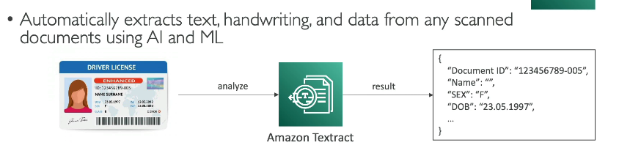

## Summary

* Rekognition: face detection, labeling, celebrity recognition
* Transcribe: audio to text (ex: subtitles)
* Polly: text to audio
* Translate: translations
* Lex: build conversational bots – chatbot
* Connect: cloud contact center
* Comprehend: natural language processing
* SageMaker: machine learning for every developer and data scientist
* Forecast: build highly accurate forecasts
* Kendra: ML-powered search engine
* Personalize: real-time personalized recommendations
* Textract: detect text and data in documents